|  |  |
| --- | --- |
| A picture of a winding road and trees  Weekly Fruit APP Final Project | **Author: Jing li**  **Student ID: 21902204** |

**Contents**

Conceptual Framework highlighting the scope of the final project 2

Screenshots of the new features 3

Advanced Feature1: Toolbar-NavigationDrawer 3

1. Layout 3

2. Behaviour 6

Advanced Feature 2: GridView and GridItemView 8

1. Layout 8

2. Behaviour 10

Constraints: 12

Strategies: 12

Testing: Unit Test , UI test , User Acceptance testing 13

Summary 22

# Conceptual Framework highlighting the scope of the final project

After I achieved the input information into a SQLite database implementation and management.

I want to see the latest iuser Detail (Updated or Deleted order information )by clicking the“Dashboard”on the NavigationDrawer in the AdminActivity to jump to a DashboardActivity.

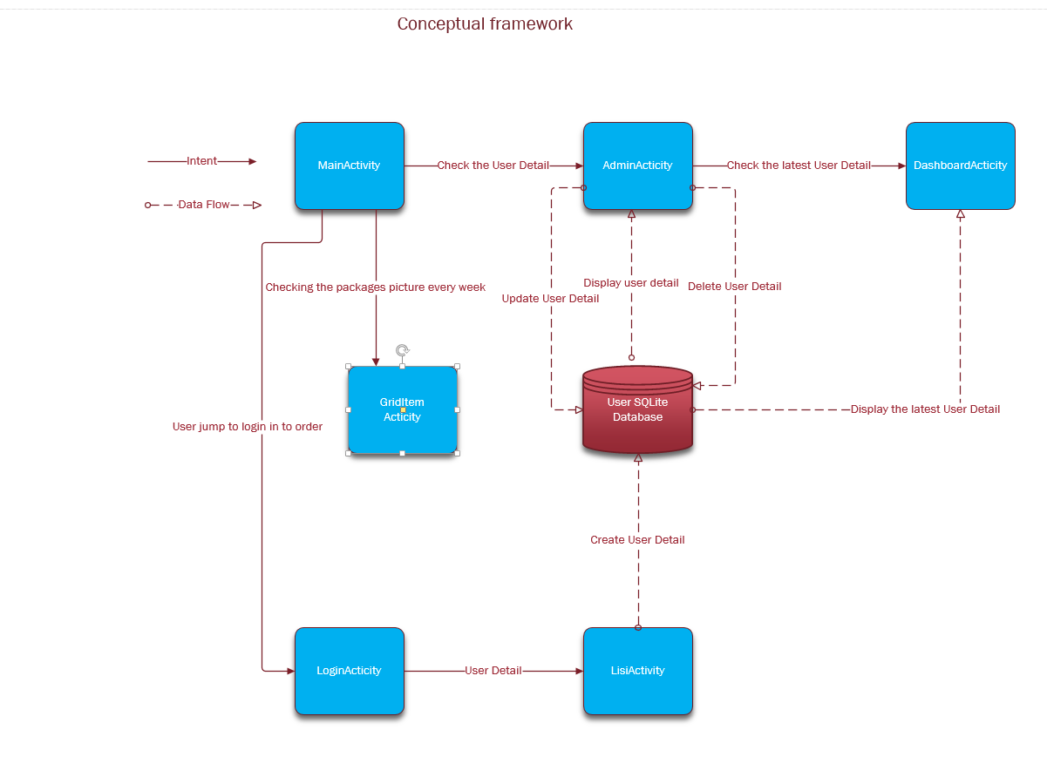

# Screenshots of the new features

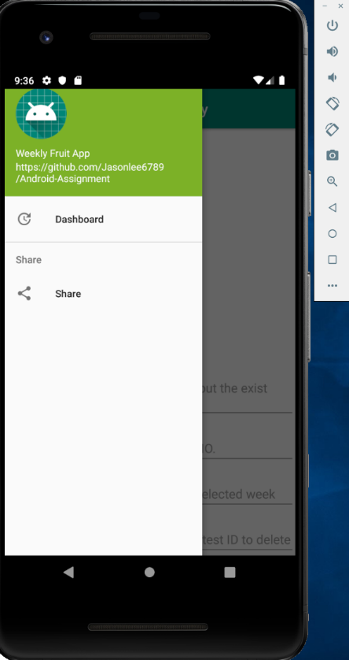 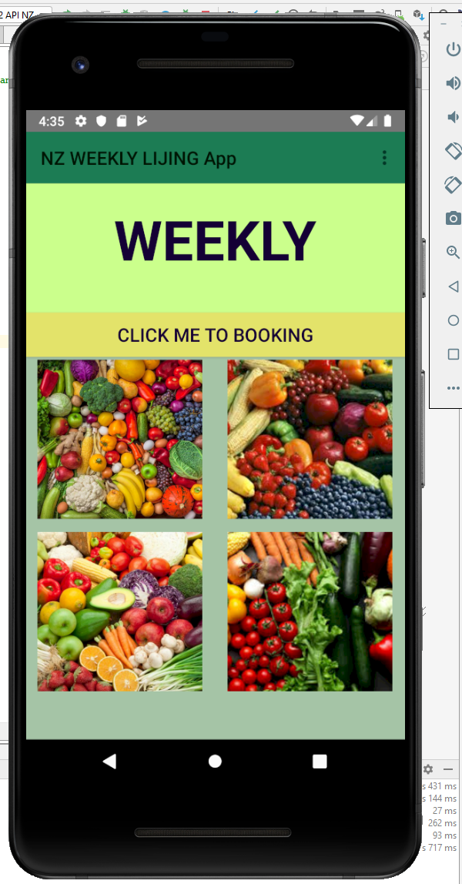

# Advanced Feature1: Toolbar-NavigationDrawer

## Layout

I add a Toolbar and a NavigationView to the activity_admin.xml.

Note: I change the layout of the activity_admin.xml to the drawerlayout.widget.DrawerLayout. NavigationView and the LinearLayout at the same level under the androidx.drawerlayo ut.widget.DrawerLayout. 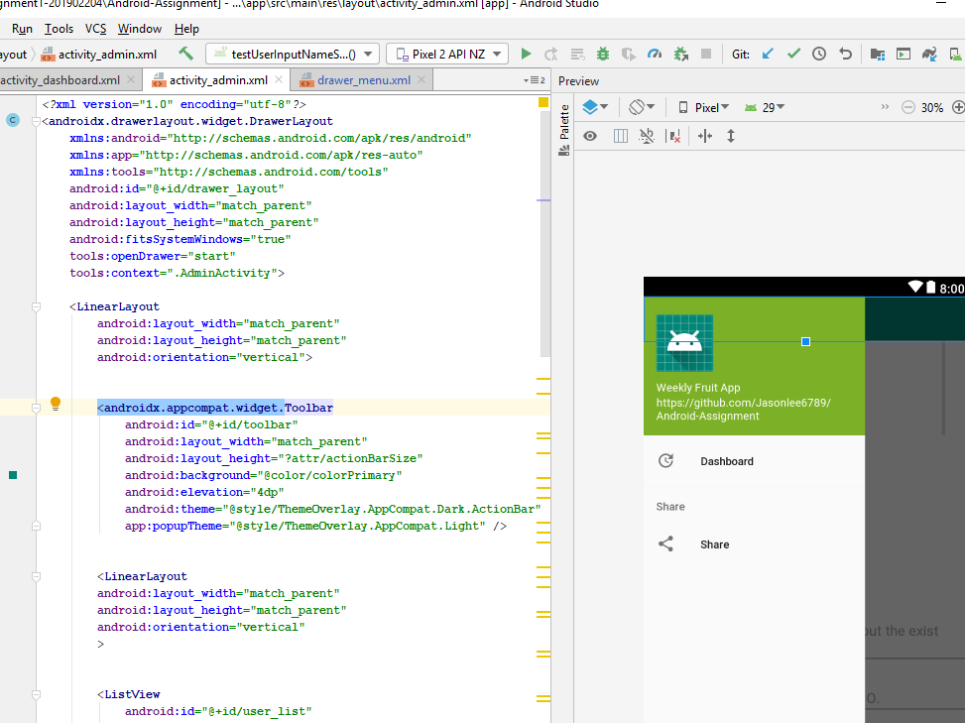 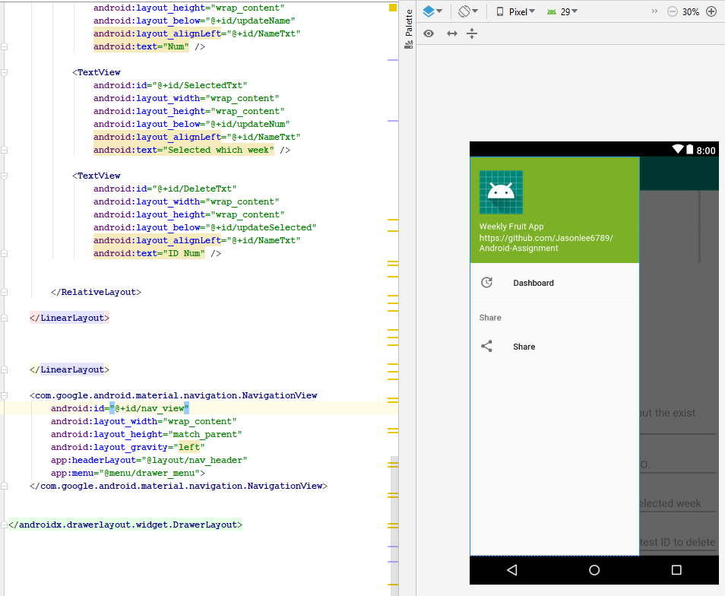

After setting the activity_admin.xml , I will add a menu in the NavigationView.

Inside the menu there are Dashboard and Share two buttons.

Dashboard is to access to the new activity, Share is to share my app .

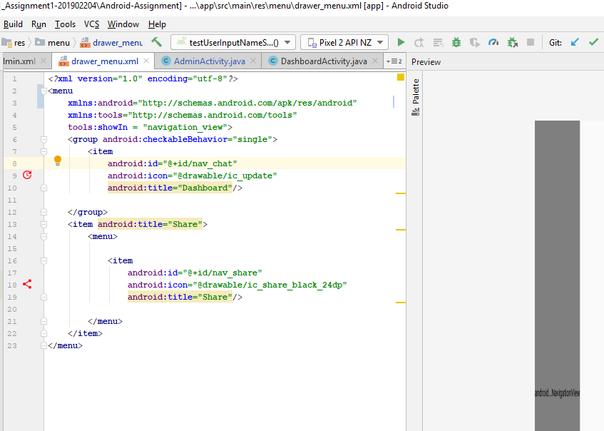

I also need add a activity_dashboard.xml，there is a ListView is to store the latest order information.and a Toolbar to show the topic of the activity.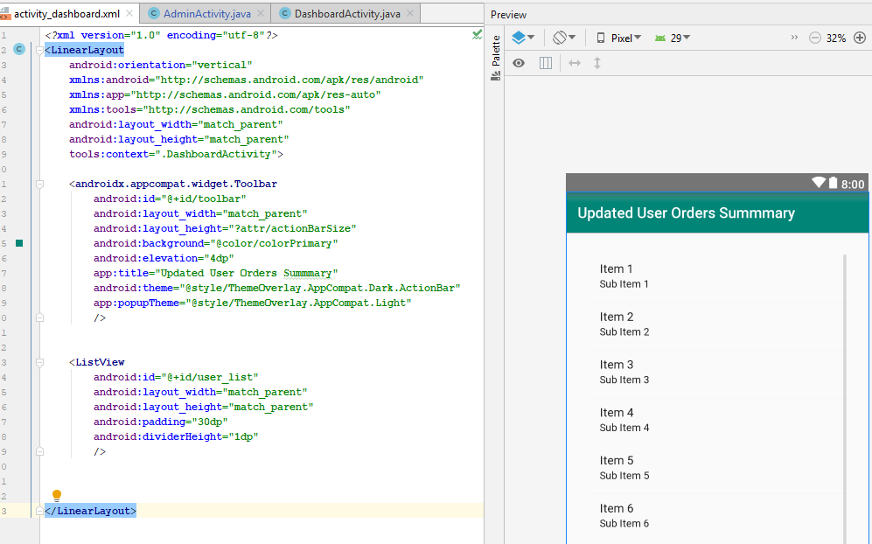

## Behaviour

In the AdminActicity.java, I will add 7 steps to achieve the drawer function .

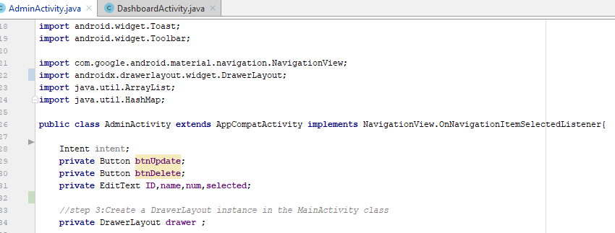

The upper is before the onCreate() method, the following steps inside onCreate() .

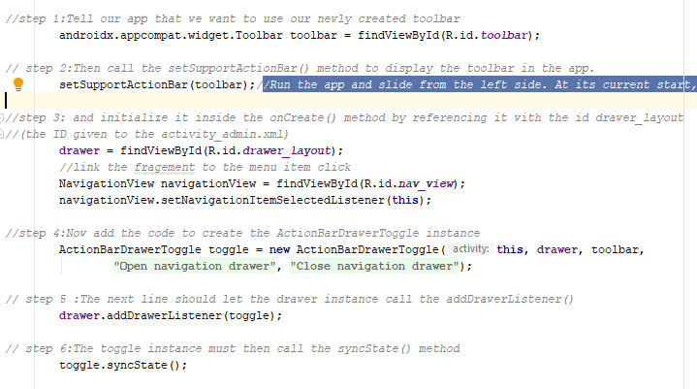

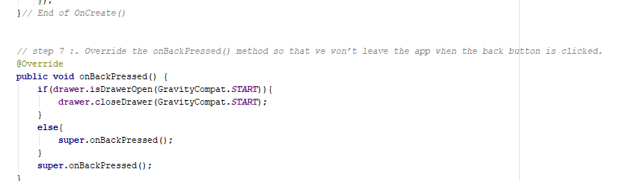

I also need make click Dashboard button is to access to the new activity, click Share button is to share app, I use a toast to replace the links view.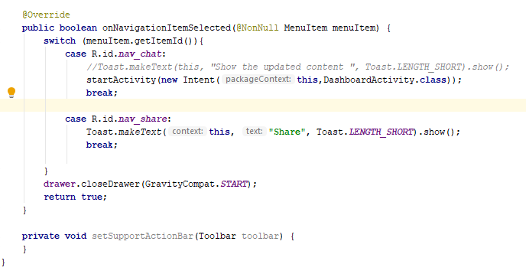

I also need make the ListView to store the newest database. So I create a database in DataboardActivity.java 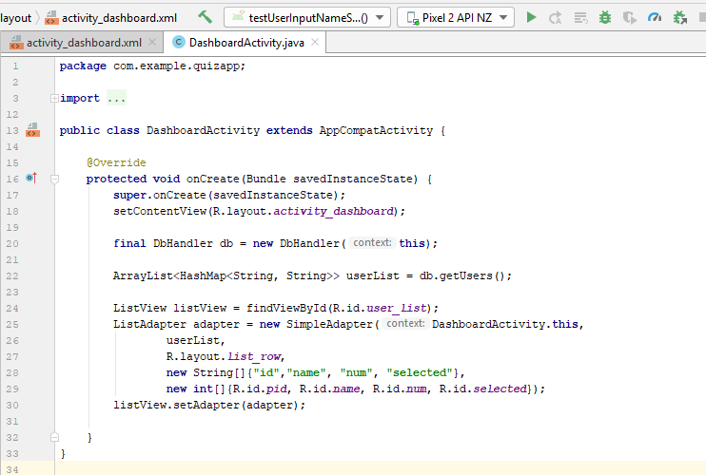

# Advanced Feature 2: GridView and GridItemView

I also want to use this display four separated packages every week one month in the AdminActivity. I achieve the navigation function : After clicking the picture of GridView in the MainActivity, it will jump to the GridItemActivity .

So I need create ImageAdapter Class to store the picture . And I also add a advanced features and concepts: GridView and GridItemView that are to display the product which user select at which week.

 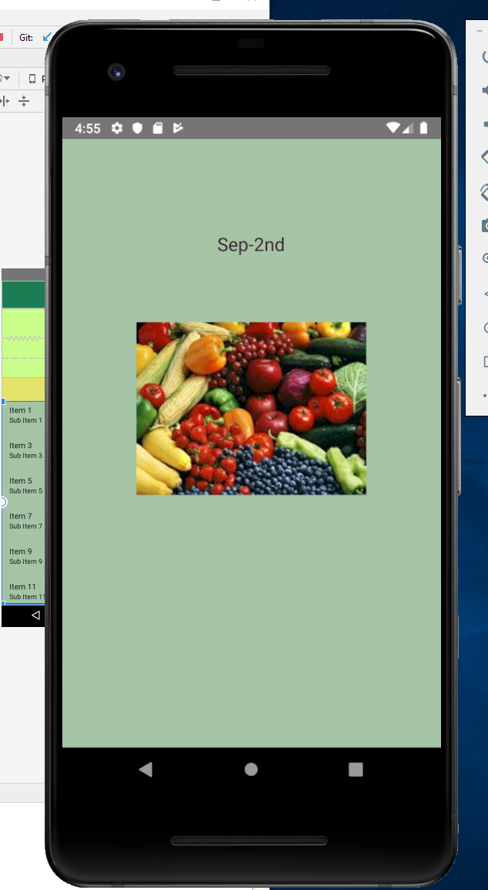

## Layout

I add a GridView in the activity_main.xml .

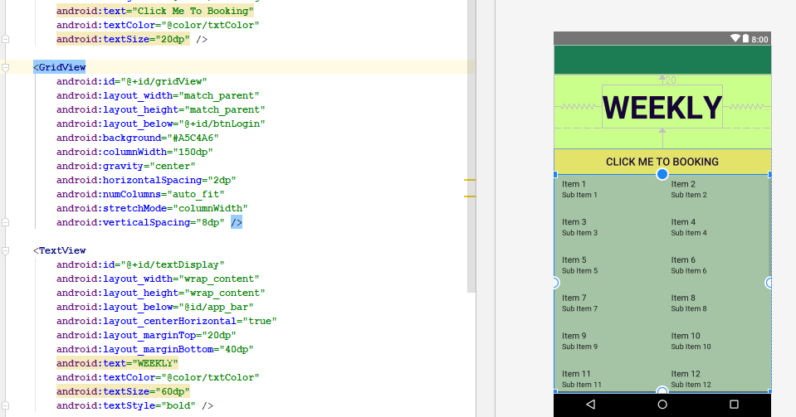

I create a activity_grid_item.xml to hold the “ImageView” and “TextView”.

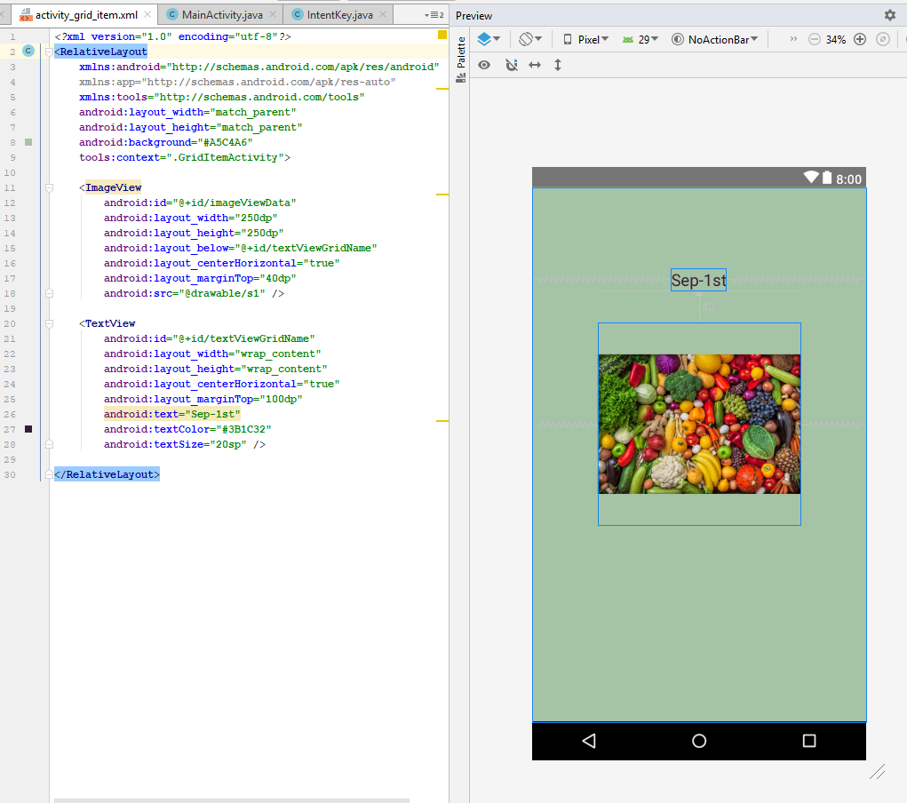

## Behaviour

I create a ImageAdapter to display 4 pictures in the gridView in the MainActivity.

Note: I make public static for the int[] image_Id ; String[] packNames to use in the MainActivity..

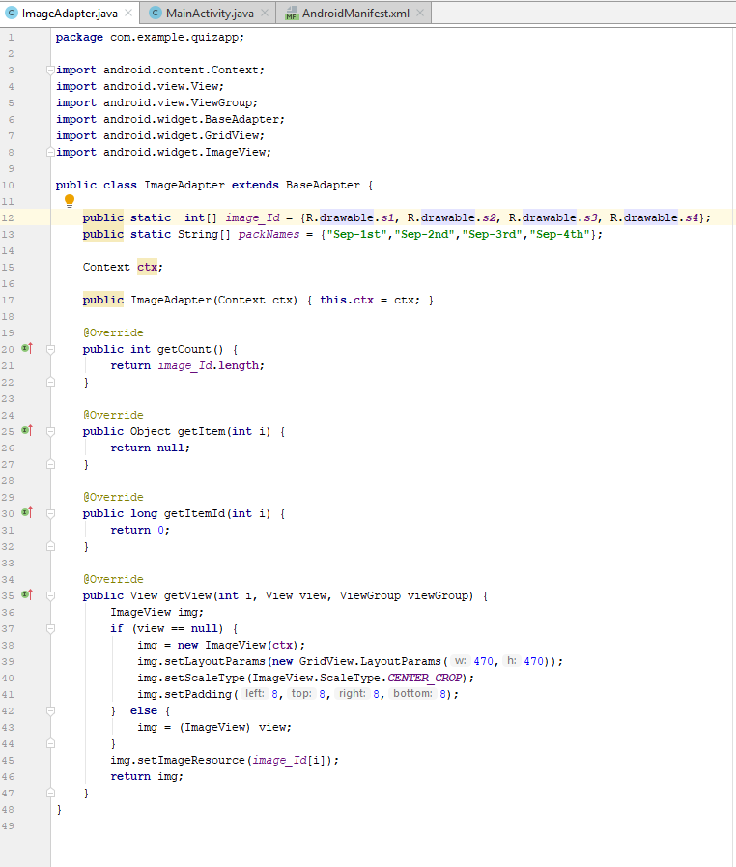

I achieve the navigation to GridItemActivity by clicking the picture .

I use the code following in the below in the MainActivity.

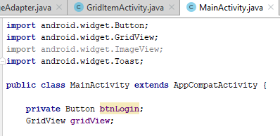

Following the “onCreate” method , I run the following code in two steps :

First step is to set the picture in the mainActivity;



Second step is to access to next activity and put the picture in the GridItemActivity.

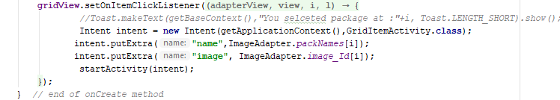

# Constraints:

The main reasons for the constraints on my development works are the lack of familiarity with the Java programming language, the strangeness of developing software in Java. This leads to the following problems

When I created a SQLite Database, I met a problem of App Version. The first time I create the SQLite Database I made a mistake losing a space at the folling part, even if afterwards I fix it , the app still ran wrong because of the version.

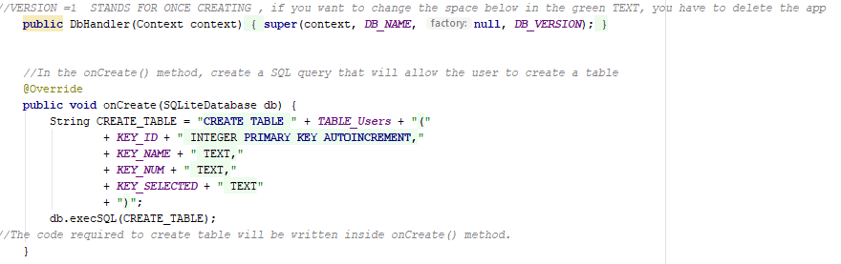

At last , I figured it out that when I changed the version ,I should delete the application in the AVD and install the app again to check the newest run result

# Strategies:

It can be made up for the lack of familiarity with the Java language by searching for information online and asking my classmates with Java development experience. The answers on the Internet are vary chaos, but the logic and code can be referenced. Next, the new code need to be tested. When experiments are buggy or fail, it is helpful to ask an experienced person or make a research on Website like StackOverflow to find the key to the error.

However, the above approach is only a palliative. Continuous learning is the most effective way to solve the problem fundamentally.

# Testing: Unit Test , UI test , User Acceptance testing

I need this UI Test to test the access to the LoginActivity after click btnLogin.

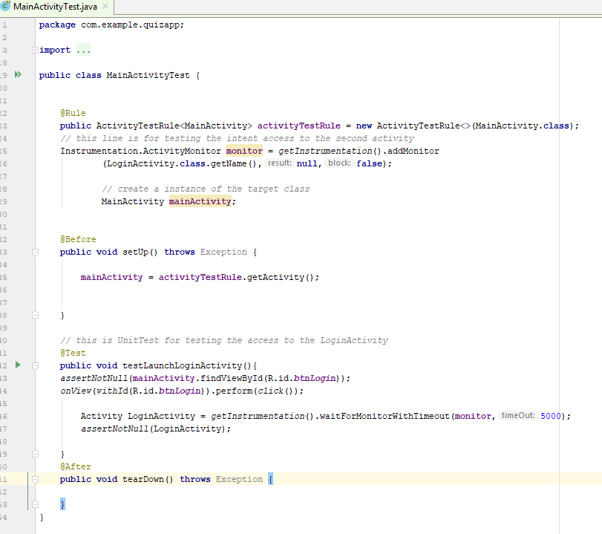

It shows successfully like the following snap picture.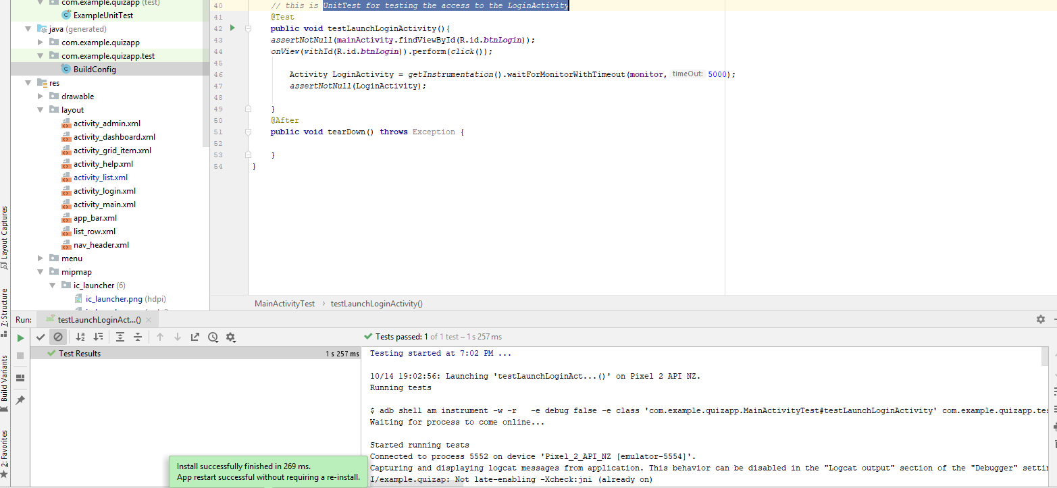

I use this UI Test to test the access to the ListActivity after hit btnGo;

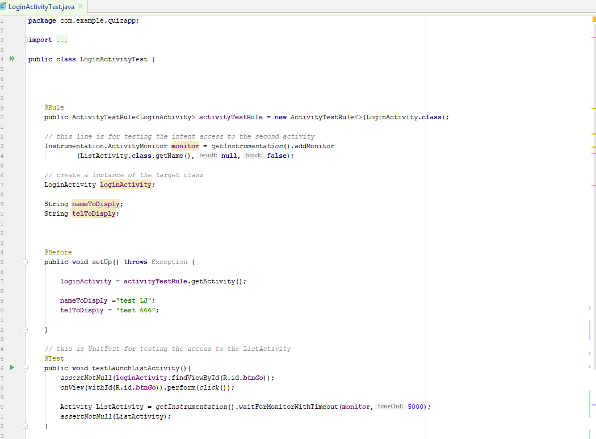

It shows successfully like the following snap picture.

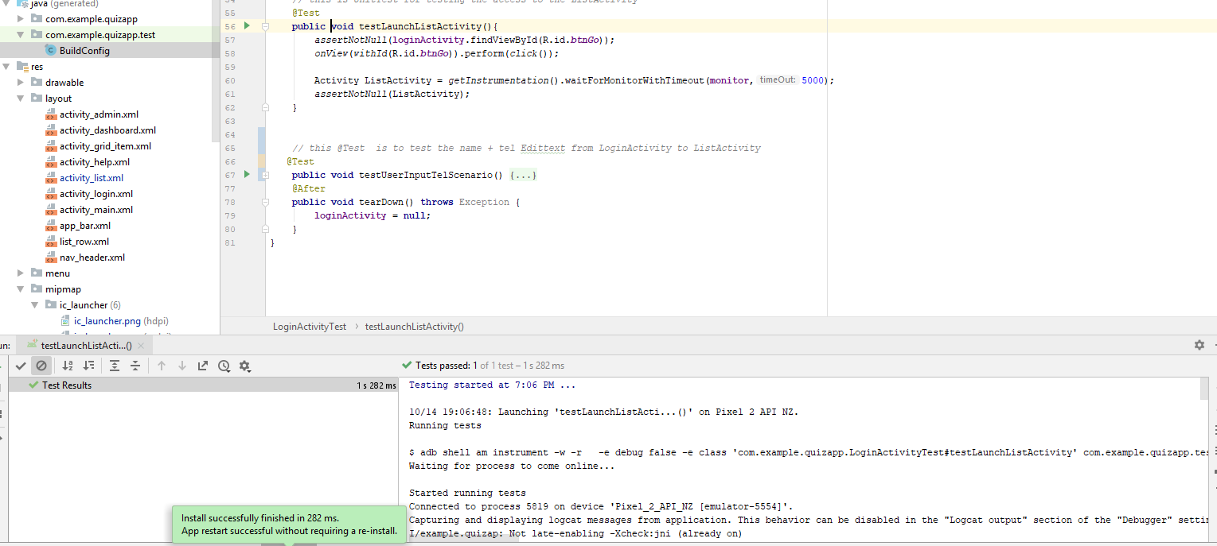

I will test two EditText, which are name and tel.

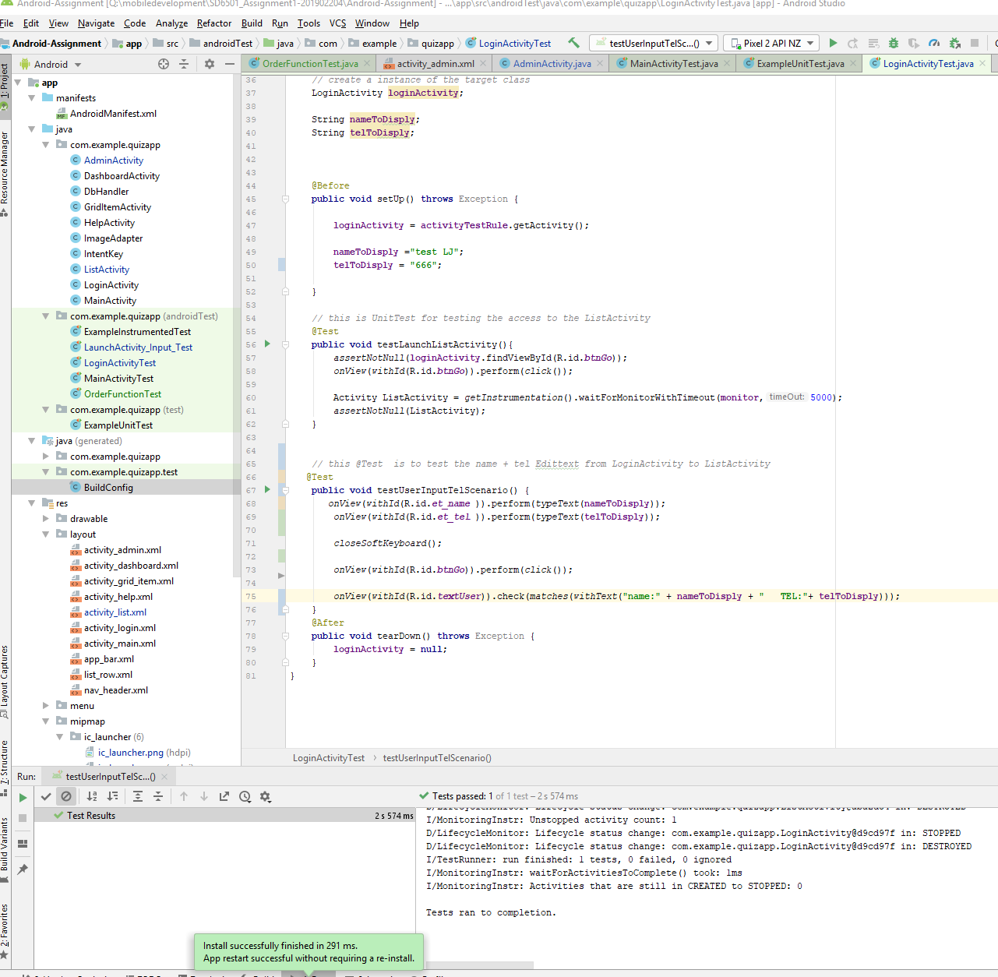

It shows successfully like the upper picture.

I use Espresso Test to test the use order function, it automatically add follows:

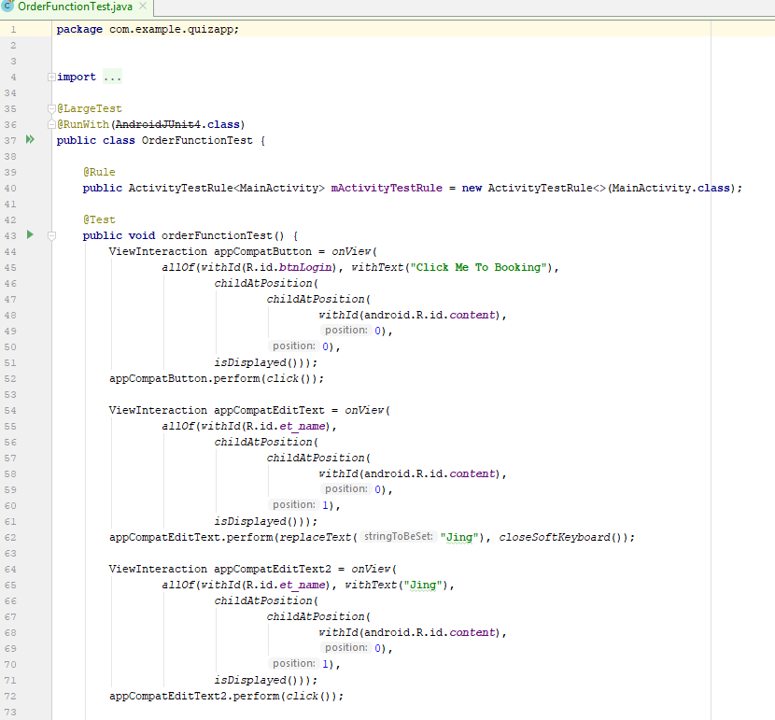

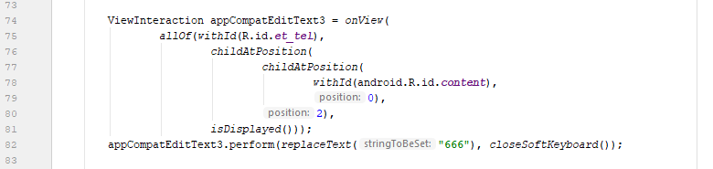

It shows successfully like the upper picture and the following pictures.

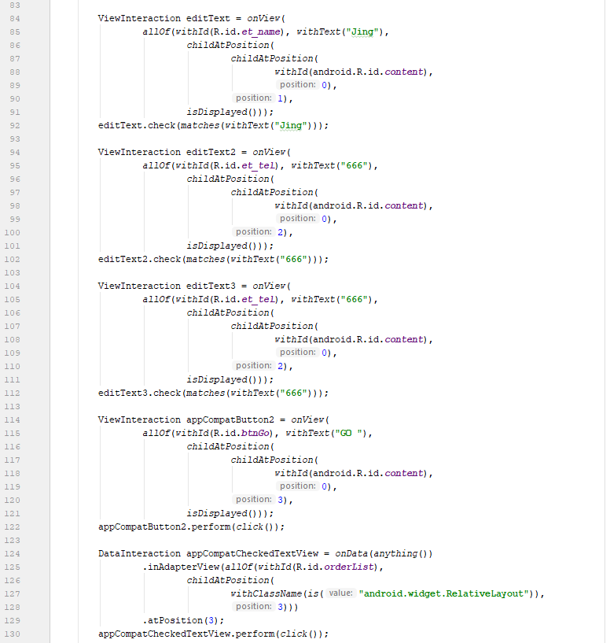

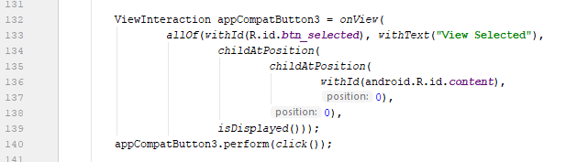

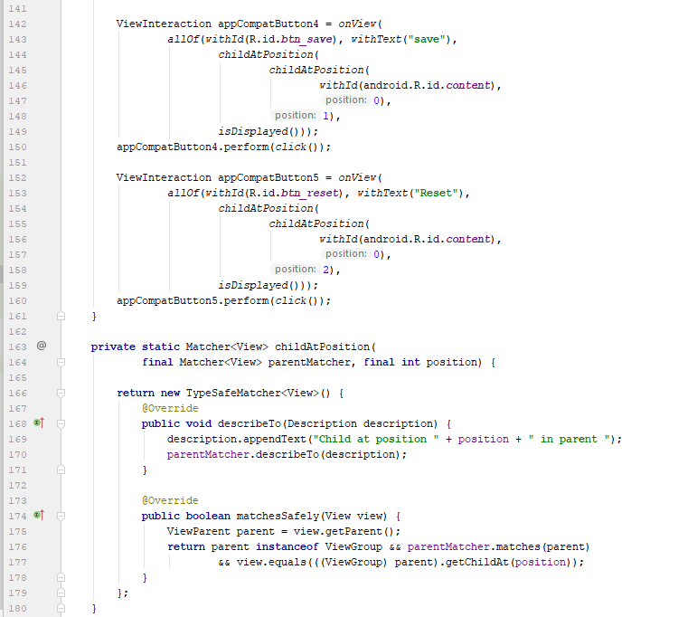

|  |  |  |  |
| --- | --- | --- | --- |
| Scenario 1 | Excepted Performance | Actural Result | (P/F)  pass / fail |
| User need to check the weekly package by hit the picture | Intent to the itemGridView | Jump to the ItemGridView | P |

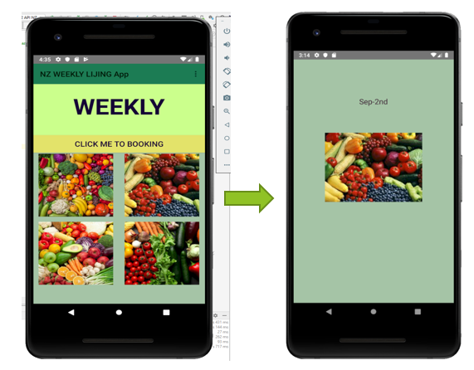

|  |  |  |  |
| --- | --- | --- | --- |
| Scenario 2 | Excepted Performance | Actural Result | (P/F)  pass / fail |
| User need to order the weekly package by hit the Go button and Input information | Intent to the next activity with the order information | Jump to the next activity and display the order information | P |

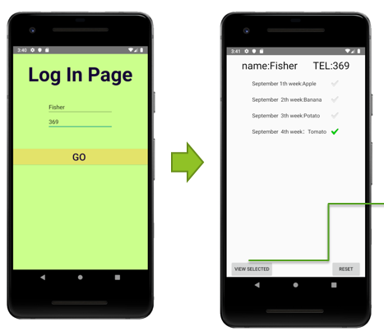

|  |  |  |  |
| --- | --- | --- | --- |
| Scenario 3 | Excepted Performance | Actural Result | (P/F)  pass / fail |
| User need to select 3th weekly package by hit the View Selected Button | Intent to new Listview activity with 3th order information | Jump to new Listview activity with 3th order information | P |

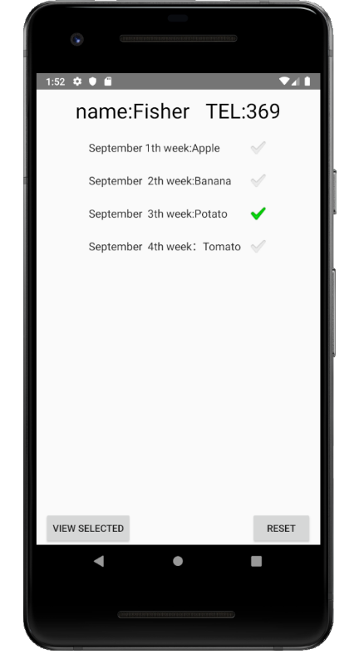 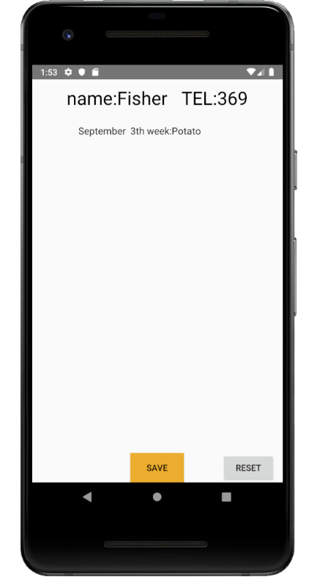

|  |  |  |  |
| --- | --- | --- | --- |
| Scenario 4 | Excepted Performance | Actural Result | (P/F)  pass / fail |
| User need to save selected weekly package by hit the Save Button | Save the order information to the SQLite | Save the order information to the SQLite like below | P |

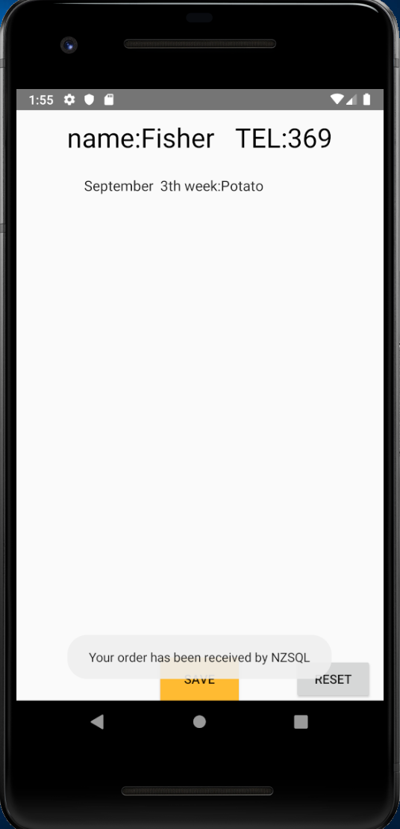 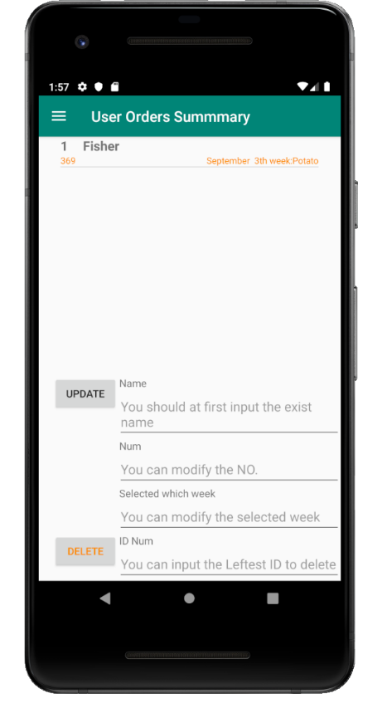

|  |  |  |  |
| --- | --- | --- | --- |
| Scenario 5 | Excepted Performance | Actural Result | (P/F)  pass / fail |
| Admin User need to see the order information by hit the Toolbar-AdminAccount menu. | See the order information from the SQLite ListView in the AdminActivity | See the order information from the SQLite ListView in the AdminActivity | P |

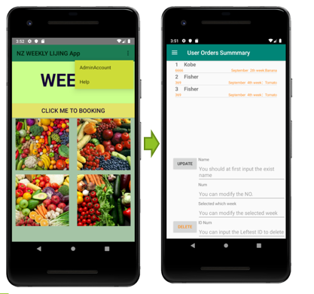

|  |  |  |  |
| --- | --- | --- | --- |
| Scenario 6 | Excepted Performance | Actural Result | (P/F)  pass / fail |
| Admin User need to update order information by hit the Update Button and hit a menu on the Drawer to check the latest order info. | See the latest order information in the DashboardActivity | See the latest order information in the DashboardActivity | P |

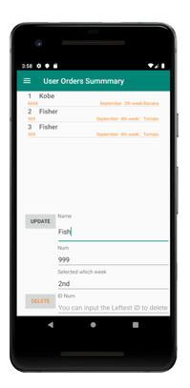 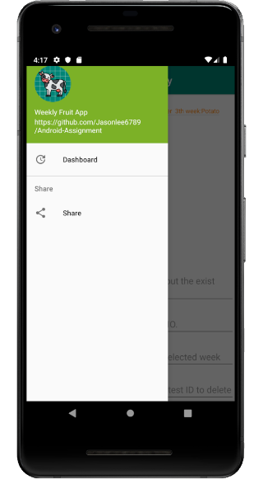 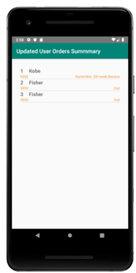

Click here text here

|  |  |  |  |
| --- | --- | --- | --- |
| Scenario 7 | Excepted Performance | Actural Result | (P/F)  pass / fail |
| Admin User need to delete order information by hit the Delete Button and hit a menu on the Drawer to check the latest order info. | Input ID 2 and hit the Delete button and See the with ID 2 order information in the Dashboard Activity. | Input ID 2 and hit the Delete button and See the with ID 2 order information in the Dashboard Activity. | P |

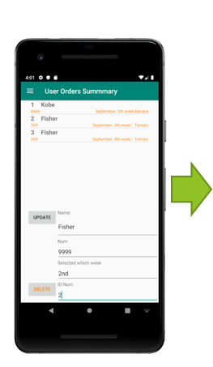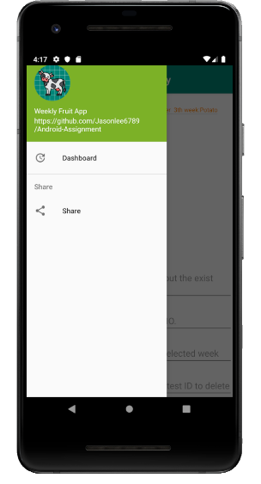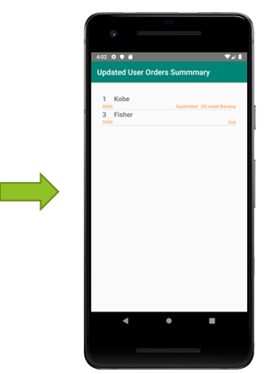

|  |  |  |  |
| --- | --- | --- | --- |
| Scenario 8 | Excepted Performance | Actural Result | (P/F)  pass / fail |
| User Click Toolbar to share or need help | Intent to the Share Toast or Help Activity | Intent to the Share Toast or Help Activity | P |

 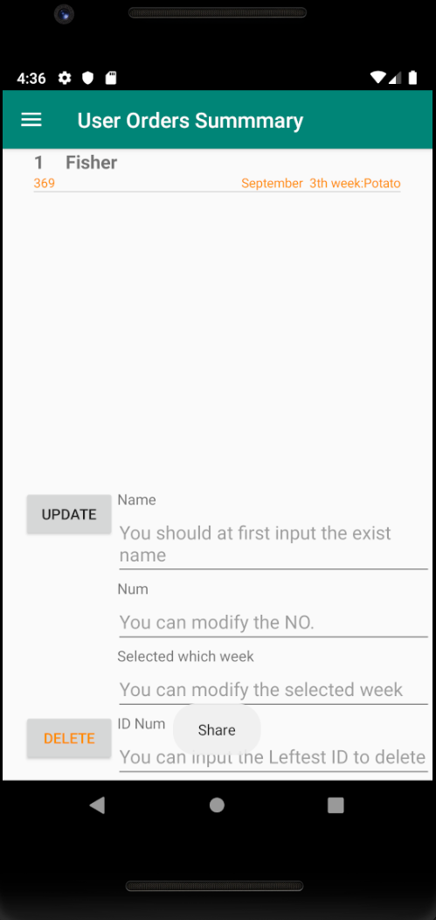 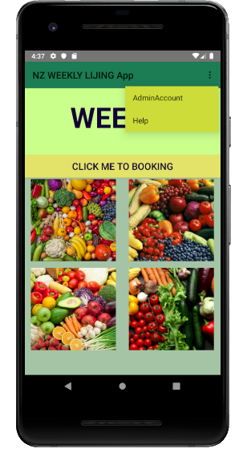 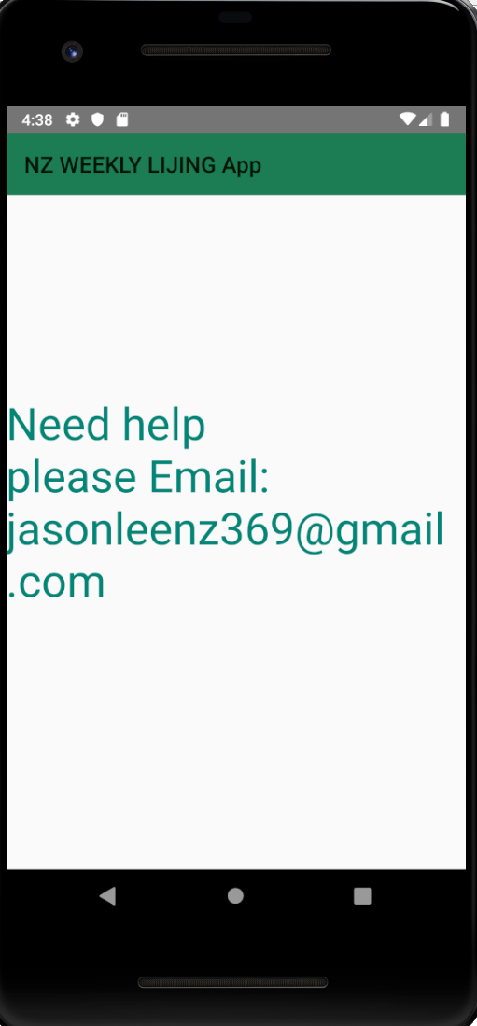

# Summary:

* Finally I complete a app to meet the requirement of a user order the weekly fruit. My App can help customer to order the weekly fruit packages from a platform.
* It solves the problem of order system only access by email, it was really inconvenient for the realtime operation.
* It also solves the order system problem that can’t be able to wander every week fruit packages in advance.
* I also mastered the Mobile Android App development with Java from a zero to a hero in the area. I am grateful for my tutor Chalinor.